Recording Recurrence, Progression and Transformation Episodes

Contents

Aim and Background……………….………………………………………………………………………...…2
Entering into Force…………………………………………………………………….………………….….…2
Definitions for Recurrence, Progression and Transformation ……….………………………………….…3
Table 1 Data items for Collection by population based cancer registries…………..……………….…....5
Table 2 Definitions of Key Data Variables ………………………………………………………..…….…….7
Work-Flow diagram solid tumours…………………………………………………………….…………….....9
Work-Flow diagram Haematological Malignancies…………………………………………………………10
Annex 1: Working Group Members……………………………………………………………………..……12

Contact: ENCR Secretariat
JRC-ENCR@ec.europa.eu

Aim
To provide recommendations for the standardised collection of data on cancer Recurrence, Progression and Transformation by population-based cancer registries (PBCR).
Background
Interest in the documentation of cancer Recurrences, Progression and Transformation (RPT) has been driven by a need to improve knowledge and outcomes for patients as the range of therapies increase and survival times continue to improve.
The identification of cancer RPT will deliver important knowledge to:
- Identify the RPT burden on cancer services and patients.
- Improve patient pathway structures post diagnosis and delivery of best care for patients.
- Facilitate research – for example linkage of data to biobank archived samples which could improve knowledge of specific cancer mutations at diagnosis/RPT and help discover better diagnostic methods and treatments.
- Facilitate RPT free survival analysis which when linked with treatment data can provide insights to improve patient outcomes.
Prior to the publication of these recommendations there were no standardised guidance for European Registries on the recording of RPT events. However, there have been requests to cancer registries for these data with some registries already making progress on this issue.

Entering into force
The new ENCR Guidance on the Recording of Recurrence, Progression and Transformation Events is published on the website on (dd/mm/yyyy). It is recommended to use this guidance for the recording of RPT events from YYYY, irrespective of the incident date of the primary cancer.

Definitions
Note: this guidance applies to all urothelial tumours and CNS tumours irrespective of tumour behaviour when the incident lesion was first diagnosed. For all other tumour site groups this guidance applies to tumours with malignant behaviour code 3 at diagnosis.
Separate guidance has been developed for haematological and solid cancers.

Cancer Recurrence - the return of cancer after a disease-free period of time post tumour-reductive treatment where the cancer had a complete clinical or microscopic response to treatment.
Cancer Progression an increase to disease load post tumour-reductive treatment where a verified complete response was not achieved.
Cancer progression `can happen in two ways:
- A patient can have a post-treatment decrease to their tumour load whereby there is macroscopic/microscopic disease present, but the overall tumour size is smaller on imaging/pathology. However, after a period of time where the disease remains stable, there is an increase to the tumour/disease load.
-Despite tumour-reductive treatments delivered the patient has no response and the treatment result is that the tumour load is bigger than when treatment commenced. Or the patient has a mixed response whereby for example the tumour reduces in size, but the affected nodes/metastasis increases in size/number.
Transformation is the diagnosis of a more aggressive morphology following a more indolent disease.
Disease Episode: Term to cover Recurrence, Progression, Transformation events.
Tumour-reductive treatment: A form of therapy given to a patient with the intention to reduce the tumour load e.g. Surgical removal of tumour, systemic therapy targeting the tumour (including monoclonal antibodies), Chemotherapy, Radiotherapy, Immunotherapy, Hormone therapy, Other or unspecified systemic therapy and Stem cell transplantation.

It should be noted that active surveillance is not treatment. The following are not considered tumour reductive therapy for the processes of recording RPT in population-based cancer registries.
- Ongoing post initial treatment hormone therapy for breast cancer (regarded as maintenance treatment),
- Active surveillance in, for example prostate cancer, thyroid or ovarian cancer monitoring.

Date of recurrence, progression, or transformation: This is defined as the first date in medical records/pathology where the RPT was diagnosed irrespective of the type of diagnostic procedure utilised.
Basis of episode gives an indication of the validity of the diagnosis This uses the same hierarchy as the ENCR Basis of Diagnosis recommendations. The highest basis should be used, and this may not necessarily correspond to the diagnostic procedure that was used to identify the date of RPT.
Histology of a recurred malignancy following microscopic examination is generally accepted as the most accurate method of cancer recurrence diagnosis. Recurrence can also be validated by other means such as radiologically, biochemically and/or clinically. The ENCR definitions for the coding of basis of cancer incidence (V2-2016) should be used for recording basis* for cancer recurrence with the following exceptions:
“Death certificate only” alone cannot be used as a basis for cancer recurrence as they are currently only viewed for cancer incidence registration.
“Specific Tumour Markers” cannot be used alone as a basis for cancer recurrence. They must be used in conjunction with an appropriate clinical opinion, or a higher prioritised basis for cancer recurrence.
Note: A rise in PSA alone may be considered as recurrence or progression in prostate cancer if combined with clinical opinion or radiology.

The “Unknown” basis cannot be used for cancer RPT registration. If a suspected RTP has an “unknown” basis, then a RTP event must not be entered on the patient’s cancer registration record.

Disease Episode Location for solid recurrence and progression tumours only:
- Local: This is the immediate area surrounding the primary tumour determined by the T-Category of the most recent recommended ENCR staging guidelines.
- Regional. This is determined by the regional lymph node classification identified as the N-Category of the most recent recommended ENCR staging guidelines.
- Distant This is determined by the M-category of the most recent recommended ENCR staging guidelines.

Table 1 Data items for collection of recurrence, progression, and transformation by Cancer Registries
It is noted that in the first instance cancer registries will not be able to collect all cancer RPT data. Thus, a Tier system has been introduced for cancer registries to be able to contribute events where data are more limited. The minimum dataset is determined by Tier 1 with Tier 2 adding additional detail where possible.
For each treatment
Data Category | Variables | Tier Allocation
Treatment Intention of primary tumour | Tumour-reductive/ non- reductive treatment or therapy/ Not Known – see table 2 for definitions | Tier1
Treatment Response of primary tumour | Complete Response/Complete Remission.  Decrease to Tumour load/Partial Response  Increase to tumour Load/Progressive disease.  Stable disease  Not Known | Tier2
Data items for each recurrence/progression/transformation

Disease Episode Type | Recurrence/Progression/Transformation | Tier 1
Date of Disease Episode | dd/mm/yyyy | Tier 1
Morphology Code of Episode | ____/3 ICD-O-3 | Tier 1 for Haematological Malignancies  Tier 2 for all other malignancies.
Disease Episode Location* | Local (Yes/No)  Regional (Yes/No)  Distant (Yes/No)  If Distant =yes, record all locations of metastasis using the organ code (first three digits) of ICD-O-3 coding | Tier 1 (Solid tumours Only)  Tier 2 (Solid tumours Only)
Tumour Grade of Episode | Differentiation grade, WHO grade, | Tier 1 for Haematological Malignancies  Tier 2 for all other malignancies.
rTNM (recurrence TNM) | Stage of Cancer as per latest ENCR recommended staging guidelines.  rT  rN  rM | Tier 2 (Solid tumours only)
Basis of Episode | As per Table 1 and Table 2 of ENCR Basis Guidelines | Tier 1

Table 2 Definitions of Key Data Variables for Recurrence, Progression and Transformation

Data Category | Associated Definition
Tumour reductive treatment | A form of therapy given to a patient with the intention to reduce the tumour load e.g. Surgical removal of tumour, systemic therapy targeting the tumour (including monoclonal antibodies), Chemotherapy, Radiotherapy, Immunotherapy, Hormone therapy, Other or unspecified systemic therapy and Stem cell transplantation. Note hormone therapy used as adjuvant maintenance therapy e.g. long-term in breast cancer is NOT included as Tumour-reductive treatment.
Disease Episode Type | Term to cover recurrence/progression/transformation events.
Basis of episode | This uses the same hierarchy as the ENCR Basis of Diagnosis recommendations. The highest basis should be used, and this will not necessarily correspond to the diagnostic procedure that was used to identify the date of recurrence, progression, or transformation ).
Date of Disease Episode | This is defined as the first date in medical records/pathology where the recurrence, progression or transformation was diagnosed irrespective of the type of diagnostic procedure utilised to diagnose the recurrence, progression, or transformation.
Disease Episode Location* | Disease Episode Location solid tumours only:  - Local: This is the immediate area surrounding the primary tumour determined by the T-Category of the most recent recommended ENCR staging guidelines.  - Regional. This is determined by the regional lymph node classification identified as the N-Category of the most recent recommended ENCR staging guidelines.  - Distant This is determined by the M-category of the most recent recommended ENCR staging guidelines.

Please see Figure 1 and Figure 2 for guidance re. recurrence, progression, and transformation pathways, how they occur and what to record. The figures below are for guidance only. Please note that if a cancer registry is not able to collect treatment intention or treatment response but does have reliable datasets which contain other Tier 1 or Tier 2 data, we advise these data are still collected.

Figure 1. Solid Tumour Recurrence and Progression Work-Flow Diagram

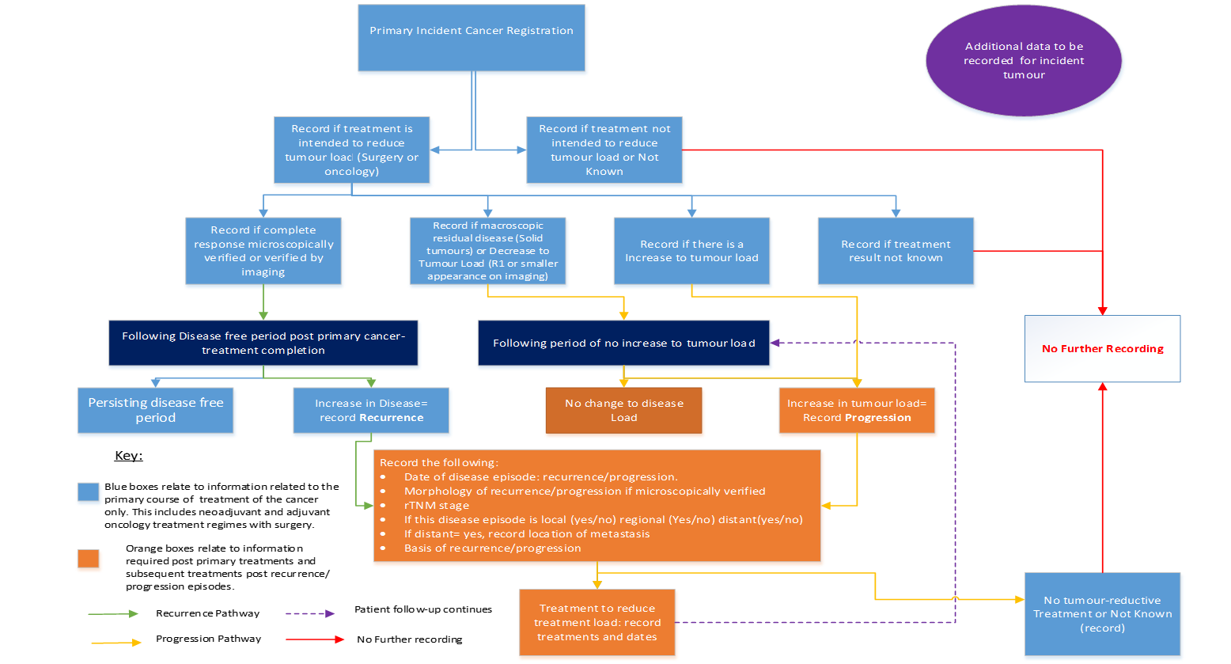
Treatment to reduce tumour load: record treatments and dates.
No further recording unless new information

Figure 2. Haematological Malignancies Recurrence, Transformation and Progression Work-Flow 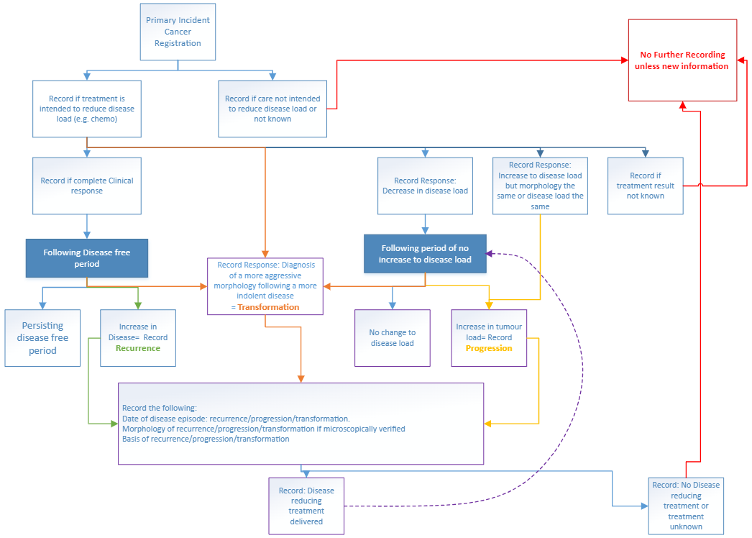
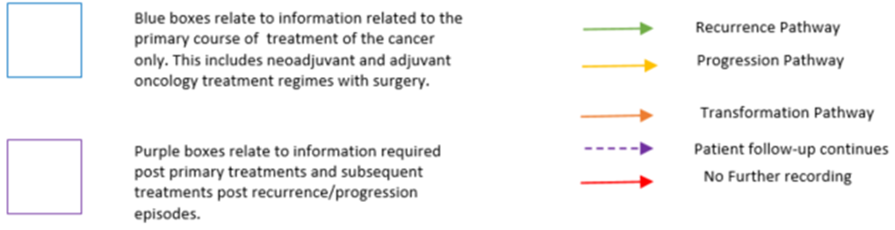

Annex 1: Working Group Members:

- Anna Gavin (coordinator), N. Ireland Cancer Registry (NICR), Queen’s University, Belfast, (UK), past ENCR Steering Committee member;
- Sinéad T Hawkins, N. Ireland Cancer Registry (NICR), Queen’s University, Belfast (UK) – Project lead;
- Damien Bennett, N. Ireland Cancer Registry, Queens University, Belfast (UK);
- Luigino Dal Maso, Cancer Epidemiology Unit, Centro di Riferimento Oncologico di Aviano (CRO) IRCCS, Aviano, Friuli Venezia Giulia Cancer Registry, Italy;
- Xavier Farré, Girona Cancer Registry, Girona, Spain;
- Francesco Giusti, Belgian Cancer Registry (Belgium), previously with European Commission Joint Research Centre (JRC), Ispra, Italy;
- Karen Graham, National Cancer Registration & Analytics Service, England, (UK)
- Dyfed Huws., Welsh Cancer Intelligence and Surveillance Unit (WCISU), (UK);
- Jenni Lai, National Cancer Registration & Analytics Service, England, (UK) ;
- Georgios Lyratzopolous, Department of Behavioural Science and Health University College London, (UK);
- Rafael Marcos-Gragera Unitat d'Epidemiologia i Registre de càncer de Girona (UERCG) Pla Director d'Oncologia. Departament de Salut;
- Carmen Martos, – Foundation for the Promotion of Health and Biomedical Research of Valencia Region (FISABIO), Spain, previously with European Commission Joint Research Centre (JRC), Ispra, Italy;
- Claire Manson, Scottish Cancer Registry (UK);
- Irmina Michalek, National Cancer Registry (Poland) ;
- David Morrison, Scottish Cancer Registry (UK);
- Luciana Neamtiu, Cluj Cancer Registry (Romania), University "Babes-Bolyai" Cluj-Napoca (Romania), previously with European Commission Joint Research Centre (JRC), Ispra, Italy;
- Raquel Negrão Carvalho, European Commission Joint Research Centre (JRC), Ispra, Italy;
- Alice Nennecke, Hamburg Cancer Registry (Germany);
- Laura Ortelli, Ticino Cancer Registry (Switzerland) ;
- Giorgia Randi, European Commission Joint Research Centre (JRC), Ispra, Italy;
- Brian Rous, National Disease Registration Service, NHS England, England (UK)
- Karen Smith, Scottish Cancer Registry (UK);
- Maciej Trojanowski, Greater Poland Cancer Center, Greater Poland Cancer Registry (Poland), member of the ENCR Steering Committee;
- Liesbet Van Eycken, Belgian Cancer Registry (Belgium), member of the ENCR Steering Committee, member of the IACR board;
- Freija Verdoodt, Belgian Cancer Registry (Belgium) ;
- Otto Visser, Netherland Cancer Registry (the Netherlands), past ENCR Steering Committee member;
- Thorsten Wicker, Hamburg Cancer Registry (Germany) ;
- Vesna Zadnik, Slovenian Cancer Registry, Ljublijana, Slovenia .

